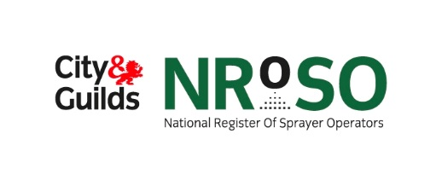

**Claiming points for achievement of your pesticide qualification**

**New Members:**

Congratulations on achieving your Pesticide Qualification. If you are wanting to join the NRoSO scheme, you can claim eight points straight away.

To join, please visit our website [**www.nroso.org.uk**](http://www.nroso.org.uk) and click on the ‘join now’ button. If you have any queries, please email **nrososupport@cityandguilds.com** or call on 02476 857300

**Member Benefits include:**

* Recognition of training and development
* Providing a professional image to the industry
* Ongoing learning opportunities
* Annual Training Event, providing you with up to date industry information, updates and networking opportunities
* Proof to Assurance schemes of up to date knowledge and compliance
* Website with latest news and online CPD statement/payment options
* Membership magazine

**Already a member?**

If you have recently achieved a further pesticide qualification enhancing your skills, you can also claim eight points for this. Once you have received your Certificate of Competence from the relevant awarding body, please call us on 02476 857300 within three months and we will update your membership (proof of your certificate may be required if achieved through Lantra).

Please note that we no longer award points for the training aspect of achieving a pesticide qualification.