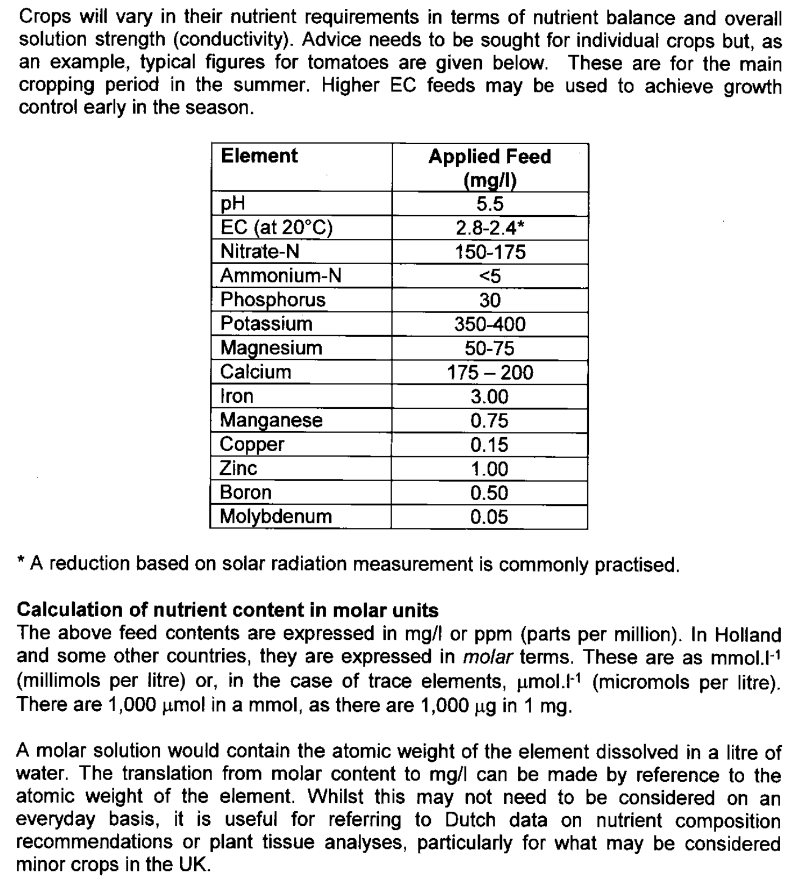

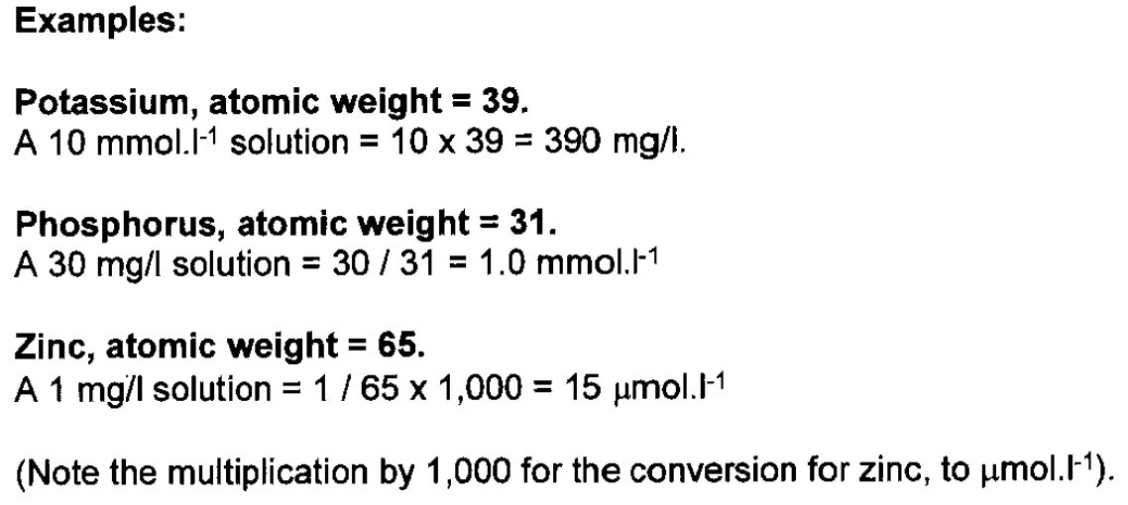

https://www.lenntech.com/calculators/molecular/molecular-weight-calculator.htm

